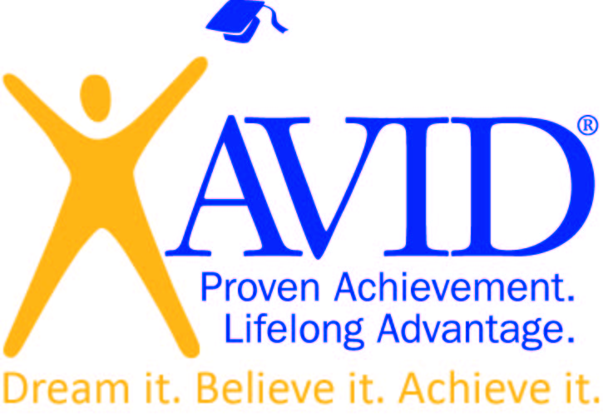

AVID is recruiting for the 2017-18 school year.

AVID's mission is to close the achievement gap by preparing all students for college readiness and success in a global society.

AVID is a program designed to achieve specific objectives:
- Support students in rigorous college preparatory programs and to enroll students in honors and advanced placement classes in high school,
- Develop the habits and skills students need to succeed,
- Develop good study habits and academic survival skills (note-taking, essay-writing, and time-management),
- Support students in maintaining grade point averages that will be competitive in applying to four-year colleges and universities,
- Foster positive attitudes toward school and higher education.

The DPMMS AVID Elective Program
- Teaches skills and behaviors for academic success,
- Provides intensive support with tutorials and strong student/teacher relationships,
- Exposes students to college and career opportunities through college visits, field trips and guest speakers,
- Creates a positive peer group for students, and
- Develops a sense of hope for personal achievement gained through hard work and determination.

We are looking for 6th, and 7th grade students that meet the following criteria:
- In the academic "middle" but has the potential to become excellent students,
- Desires to succeed academically,
- Generally follows school rules and expectations, and
- Not a member of any magnet programs.
If you are interested in AVID please submit a completed application no later than 3:00pm July 17, 2017, to:
Mrs. L. Gooden
Deer Park Middle Magnet School
9830 WInands Road
Randallstown, Maryland 21133
OR
Lgooden@bcps.org
Want more information about AVID? Visit the Office of College and Career Readiness on the BCPS Website!

